WRWD Overall Map

Viewing Approved Permits
Go to our website at: www.wildricewatershed.org
Click on Wild Rice Watershed District Overall Map

Under map layers, click Approved Permits to turn the layer on:
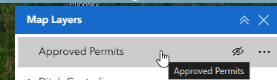

The approved permits are marked with a red dot. Click on the dot for permit information:
