WRWD Data Access Point (M-Files)

Viewing Permit Tables
Go to our website: www.wildricewatershed.org
Click on WRWD Data Access Point
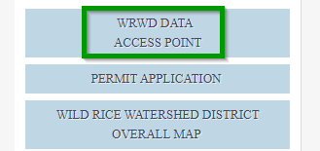
The first screen shows “Common Views”. Common Views were created for quick access to frequently accessed documents.
Double click on the category you’d like to view. In this case either Permit Tables (Preliminary) or Permit Tables (with Board Actions)
Note: Prior to January 2024, Preliminary Permit Tables were not uploaded to this database.
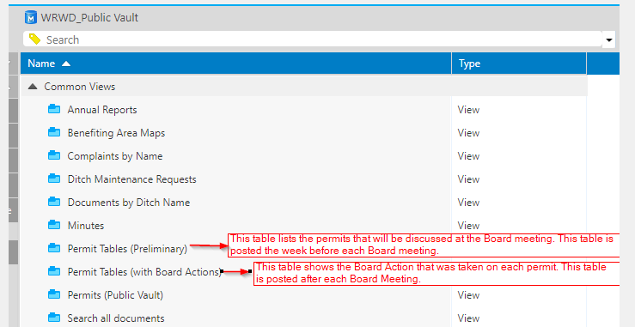

The next screen lets you choose the year:
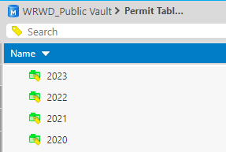
The next screen displays the permit tables for that year:
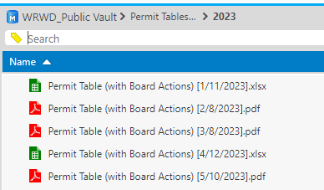

There are 2 ways to view the files:
To Preview: click once to highlight the file and click the “Preview” tab on the right side of the screen-
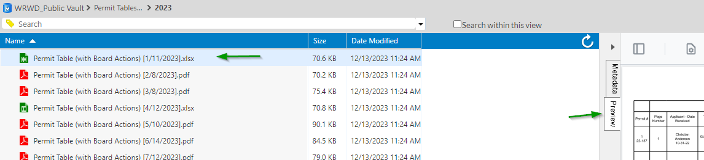

To download the file: double click on the name of the file you wish to download.

Searching for Permits

To search for a Permit using the Permit number:
Type the Permit # in the search box and press ENTER.
You’ll see a list of results under the “Documents” section BUT that section could include documents that are unrelated to the permit. For the most accurate results and follow these steps:
Click the arrow next to “Permits (Houston Engineering)” to expand that section,
click the arrow next to the permit # you are searching for to expand that section & finally, click the arrow next to Documents
(see the green boxes in the illustration below for reference)
Now you can see every document filed under that Permit #
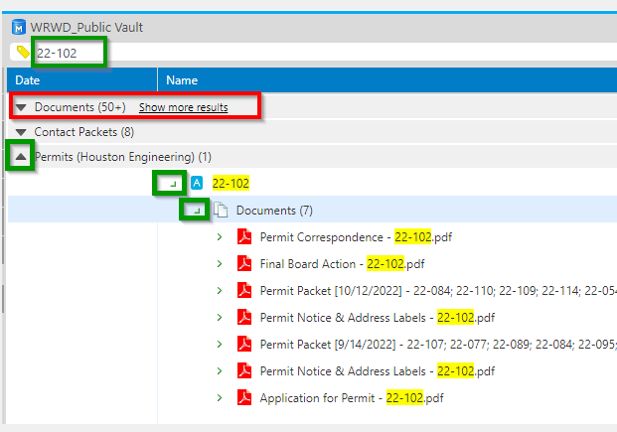

To search for a Permit by year, County and Township:
Double click on the Permits (Public Vault) folder under Common Views & double click your selection.
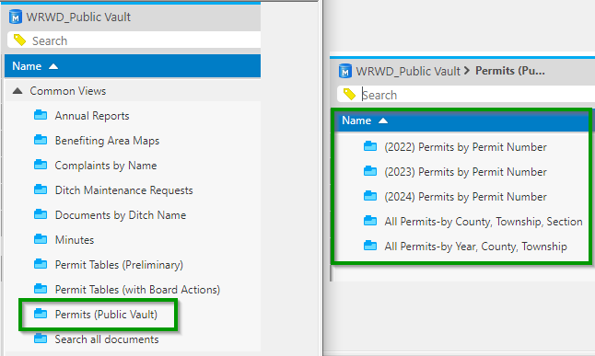

Expand the arrows to view the documents:
